PORTOFLIO PROJECT #02
Comparative analysis of NIFTY 50 Index and its constituents from 2015 to 2025 with Pre COVID and Post COVID impact.

Business Questions and Insights.
Q1. Which regime had better performance, was it Pre-COVID or Post-COVID?
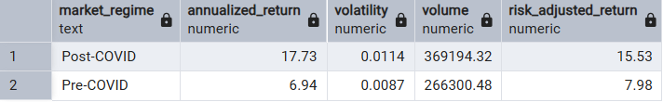
Returns Nearly Tripled Post-COVID
- Pre: ~7%
- Post: ~18
Risk Increased
- Volatility ↑ from 0.0087 → 0.0114
- But returns ↑ much more
(Heightened investor participation despite increase in volatility)

Risk-Adjusted Performance Doubled
- 7.98 → 15.53
(Investor was rewarded for the risk taken)
Participation Increased
- Volume ↑ ~38%
(Volume of trades increased showcasing higher participation of investors which in term supports increase in trade capital)

Post-COVID markets delivered significantly higher and more efficient returns, supported by increased participation, despite higher volatility

Q2: Which stocks delivered the best risk-adjusted returns and in which regime?
(“Best bang for buck” considering risk + time)

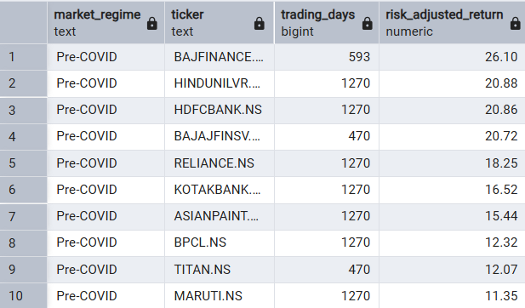
During the Pre-Covid period BAJAJFINANCE, HINDUUNILVR, HDFCBANK, BAJAJFINSV, RELIANCE, KOTAKBANK, ASIANPAINT, BPCL, TITAN AND MARUTI having a trading period of greater than 252 days are the top 10 stocks which delivered the best returns per unit risk.

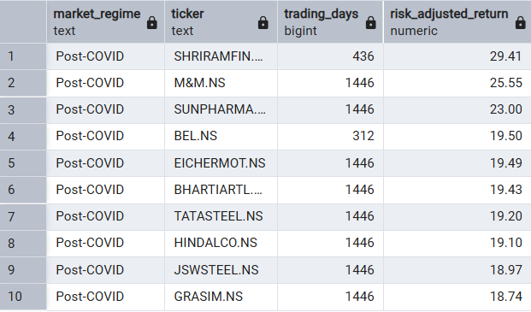

During the Post-Covid period, SHRIRAMFIN, M&M, SUNPHARMA, BEL, EICHERMOT, BHARTIARTL, TATASTEEL, HINDALCO, JSWSTEEL AND GRASIM, having a trading period of greater than 252 days are the top 10 stocks which delivered the best returns per unit risk.

Risk-adjusted leadership shifted from defensive quality stocks pre-COVID to cyclical and growth sectors post-COVID, reflecting a structural change in market behaviour.

Q3: Was it riskier to trade Pre-COVID or Post-COVID?
(Volatility + Liquidity Perspective)

Index level volatility and volume
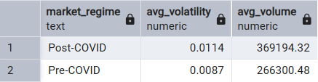
- Volatility ↑ ~30%
- Volume ↑ ~38%
At the index level, post-COVID markets became significantly more liquid but also more volatile signifying more activity and more risk.

Stock level volatility, volume dispersion and volume
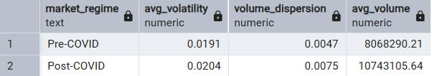
- Volatility ↑ ~30%
- Average volatility ↑ ~7%
- Dispersion (0.0047 → 0.0075)
Not only did risk increase at stock level but there was increase in overall dispersion as well, signifying uneven risk across different stocks.
Post-COVID markets became more liquid but also more volatile at the index levels. At the stock level, volatility dispersion increased significantly, indicating uneven risk distribution across constituents. This post-COVID markets more attractive for active traders but riskier for conservative investors, signifying that markets were riskier but also smoother to trade.

Q4: Which stocks outperformed/underperformed the NIFTY 50 Index?
Distribution of Performance
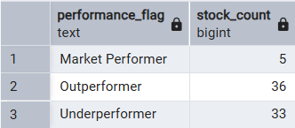
Only about half of NIFTY 50 constituents managed to beat the index, while the other half underperformed, confirming that consistent outperformance is difficult.

“Moderate Return, Long Exposure”
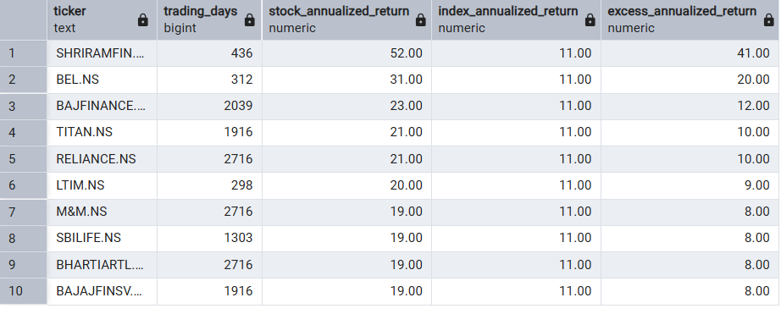SHRIRAMFIN, BAJAJFINANCE, TITAN, RELIANCE, M&M, BHARTIARTL, BAJAFINSV, SBILIFE ADANIPORTS, HINDALCO are the top 10 stocks which outperformed the Index having a trading period greater than 252 days.
“High Return, Short Exposure companies”
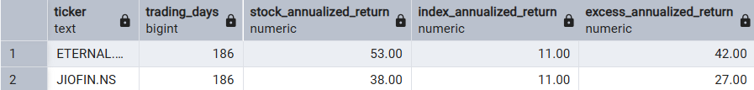
ETERNAL, JIOFIN, BEL and LTIM are the only to stocks which outperformed despite having a short trading period of less than 252 days.

“Short Exposure, Underperformance”
NMDC is the only stock which underperformed having a trading period of less than 252 days.

“Long Exposure, Underperformance”
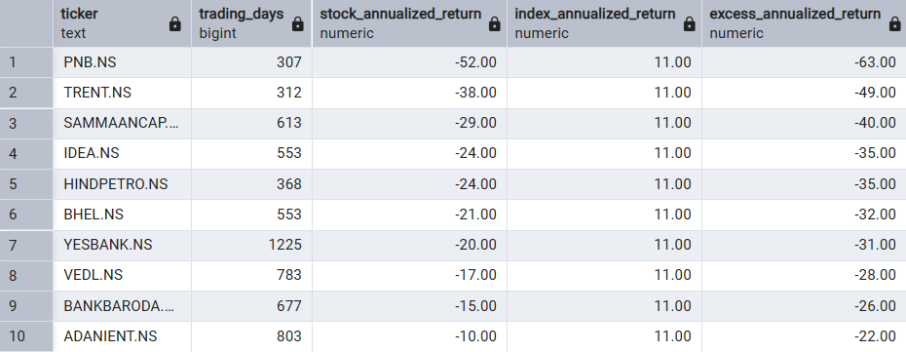
PNB, TRENT, SAMMANCAP, HINDPETRO, IDEA, BHEL, YESBANK, VEDL, BANKBARODA, ADANIENT are top 10 stocks which underperformed having a trading period of more than 252 days.

While several stocks generated high excess returns over short periods, only a few large-cap leaders consistently outperformed the index over long membership periods, highlighting the difficulty of sustained alpha generation.

Q5. How Severe were Downside Risks?
(Maximum Drawdowns of Stocks vs Index, Pre vs Post COVID)

Index level Maximum Drawdown
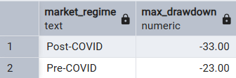
Post COVID market corrections were deeper even though returns were higher. This suggests returns also come with a downside risk.

Top 10 stocks with their respective max drawdown - Pre COVID
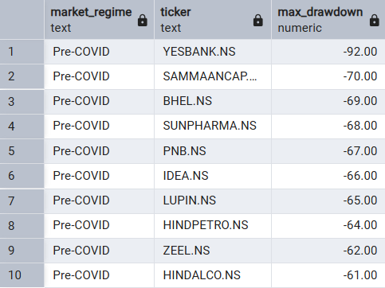

Top 10 stocks with their respective max drawdown - Post COVID
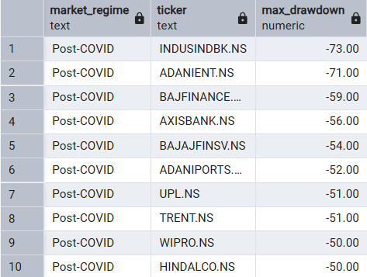
While post-COVID markets delivered higher returns, they also experienced deeper index-level drawdowns. At the stock level, extreme losses occurred in both regimes, highlighting significant risk in individual stocks, reinforcing the idea of portfolio diversification and risk management.

